Activity Diagram
Activity Diagrams describe how activities are coordinated to provide a service which can be at different levels of abstraction. Typically, an event needs to be achieved by some operations, particularly where the operation is intended to achieve a number of different things that require coordination, or how the events in a single use case relate to one another, in particular, use cases where activities may overlap and require coordination. It is also suitable for modeling how a collection of use cases coordinate to represent business workflows
- Identify candidate use cases, through the examination of business workflows
- Identify pre- and post-conditions (the context) for use cases
- Model workflows between/within use cases
- Model complex workflows in operations on objects
- Model in detail complex activities in a high level activity Diagram
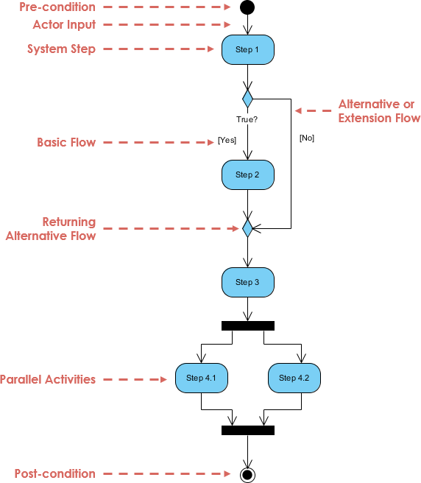
Activity Diagram - Modeling a Word Processor
The activity diagram example below describes the workflow for a word process to create a document through the following steps:
- Open the word processing package.
- Create a file.
- Save the file under a unique name within its directory.
- Type the document.
- If graphics are necessary, open the graphics package, create the graphics, and paste the graphics into the document.
- If a spreadsheet is necessary, open the spreadsheet package, create the spreadsheet, and paste the spreadsheet into the document.
- Save the file.
- Print a hard copy of the document.
- Exit the word processing package.
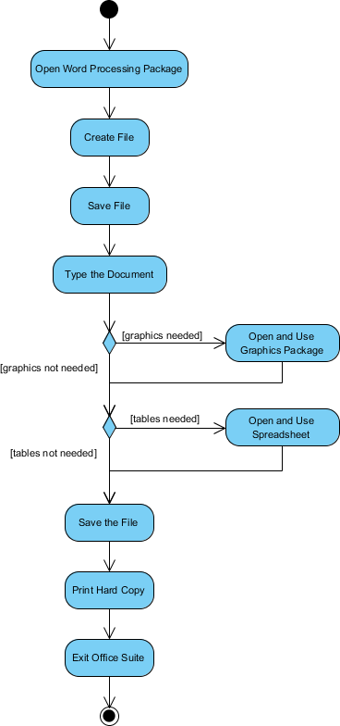
Activity Diagram Example - Process Order
Given the problem description related to the workflow for processing an order, let's model the description in visual representation using an activity diagram:
Process Order - Problem Description
Once the order is received, the activities split into two parallel sets of activities. One side fills and sends the order while the other handles the billing.
On the Fill Order side, the method of delivery is decided conditionally. Depending on the condition either the Overnight Delivery activity or the Regular Delivery activity is performed.
Finally the parallel activities combine to close the order.
The activity diagram example below visualize the flow in graphical form.
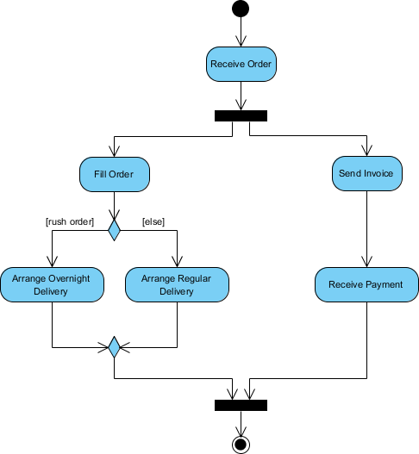

Activity Diagram - Swimlane
A swimlane is a way to group activities performed by the same actor on an activity diagram or activity diagram or to group activities in a single thread. Here is an example of a Swimlane activity diagram for modeling Staff Expenses Submission:
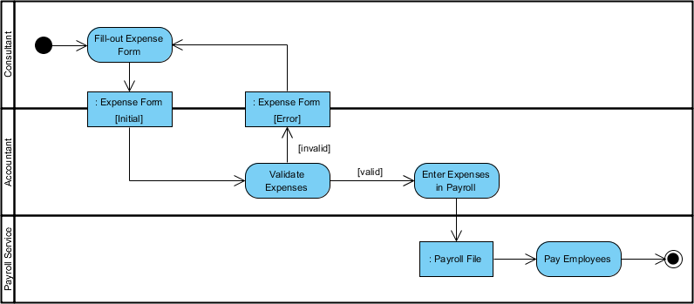
Swimlane and Non-Swimlane Activity Diagram
The activity diagram example below describes the business process for meeting a new client using an activity Diagram without Swimlane.
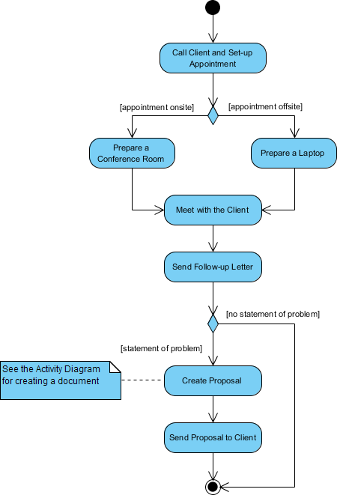
This figure below describes the business process for meeting a new client using an activity Diagram with Swimlane.
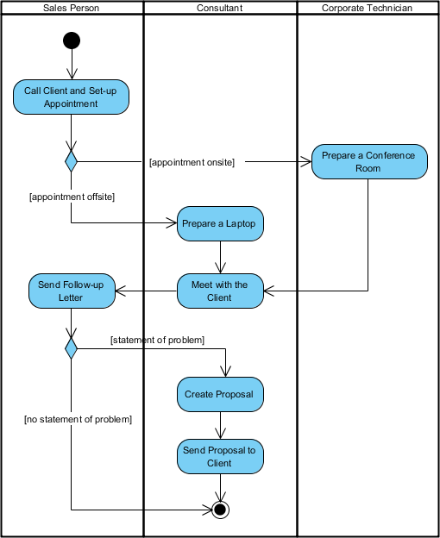
Activity Diagram Notation Summary
Notation Description | UML Notation
Activity: Is used to represent a set of actions | 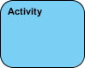
Action: A task to be performed | 
Control Flow: Shows the sequence of execution
Object Flow: Show the flow of an object from one activity (or action) to another activity (or action).
Initial Node: Portrays the beginning of a set of actions or activities
Activity Final Node: Stop all control flows and object flows in an activity (or action)
Object Node: Represent an object that is connected to a set of Object Flows | 
Decision Node: Represent a test condition to ensure that the control flow or object flow only goes down one path | 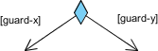
Merge Node: Bring back together different decision paths that were created using a decision-node. | 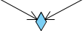
Fork Node: Split behavior into a set of parallel or concurrent flows of activities (or actions) | 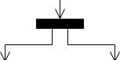
Join Node: Bring back together a set of parallel or concurrent flows of activities (or actions). | 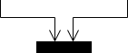
Swimlane and Partition: A way to group activities performed by the same actor on an activity diagram or to group activities in a single thread | 